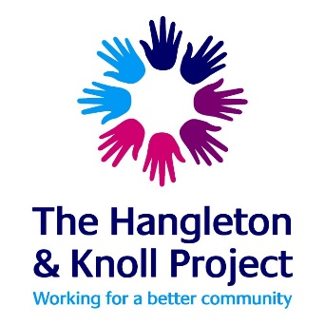
Closing date Extended to 10am on Monday 2nd August
The Hangleton and Knoll Project is a nationally recognised and award winning Community Development and Youth Work charity; based in the Hangleton and Knoll ward of Brighton and Hove in South East England. A part of the community since 1983 we are a project working for the community with the community and managed by the community.

Since the outset local residents have shaped and developed the project to become what it is today; a model of good practice for how a community is able to develop and manage its own resources

The Hangleton and Knoll Project are seeking an experienced Youth Worker to join our friendly team in the West of the City

15-25 hours per week, spinal point 13 – 24, £22,627 to £28,672 pro-rata pa salary dependent on qualification/ experience.

Are you up for being part of an award winning, values based community run offer? Do you believe in all young people getting the opportunities they deserve? Join us and you will be part of the team working to make this happen.

The application pack is available for down load on the vacancies button on the front page of our web site http://www.hkproject.org.uk
All completed applications by email to: info@hkproject.org.uk

Closing date Extended to 10am on Monday 2nd August
Interviews on Monday 16th August

If you would like more information, please email Helen Baxter Youth Coordinator helen.baxter@hkproject.org.uk giving your best contact number for a call back.

