West Area Health Forum
Wednesday 15 July 2020, 10-12 via Zoom (online meeting)

- Welcome and introductions
There were 29 people in attendance. Apologies were received from Richard (Practice Manager at Hove Medical Centre) and Dr Rowan (GP at Portslade Medical Centre and West Area Primary Care Network (PCN) Clinical Lead).
Jo reported that, since the last Forum, the Hangleton and Knoll Project (HKP) had adapted in response to the coronavirus lockdown by:
- transitioning its services online, including youth work outreach;
- Offering help with IT through its Community Learning team;
- Setting up an Emergency Food Hub at St Richard’s;
- Calling all older people to complete a needs assessment;
- Setting up a new service of volunteers to help with food shopping and telephone befriending; and
- Re-establishing its detached youth work outside in June 2020, including socially-distanced ‘walk and talks’, to support younger people during lockdown.
Further details about all of HKP’s current offers can be found in the image below.
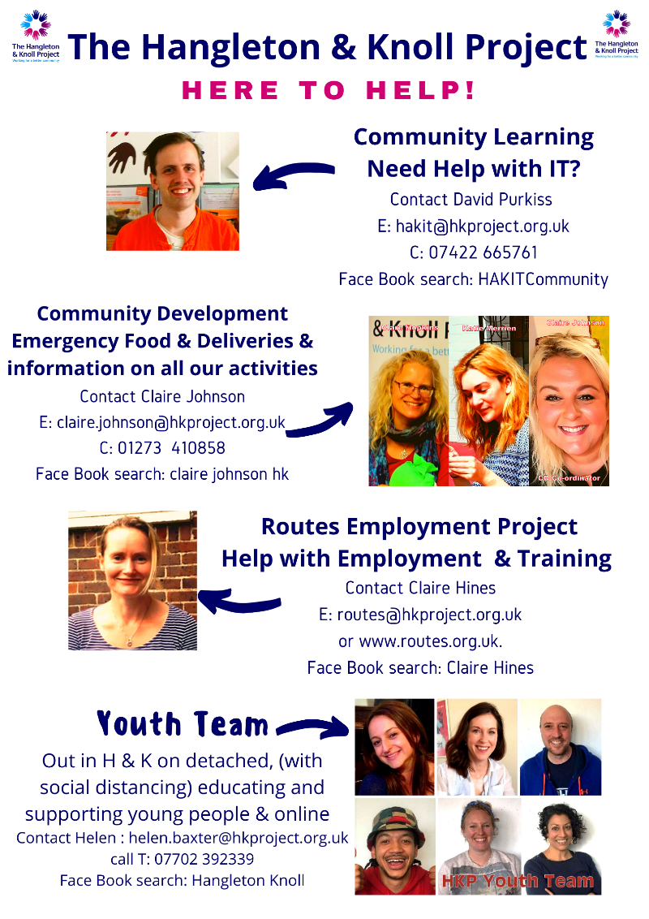

Jo reported HKP was doing a door-knocking consultation with local residents, to find out how people were doing and what they want from HKP’s Community Learning, which was identifying a lot of additional needs for local residents.

Please contact Forum facilitator Joanna (JM) on joanna.martindale@hkproject.org.uk or 01273 881446 at any time with agenda ideas, comments, feedback or questions.

- Primary Care Network (PCN) and Patient Participation Group (PPG) Network
Sharon (HKP Health Champion and the West Area PCN’s Patient Representative) reported the PCN was still meeting regularly, and was currently trying to gather patients’ feedback about the shift from face-to-face to online (e-consultation) appointments in GP Surgeries as a result of the coronavirus lockdown.

Martyn gave assurance that NHS Brighton and Hove Clinical Commissioning Group (B&H CCG) had insisted that any GP Surgery that was only offering e-consultations re-instated other methods for patients to access appointments, as some people could or would not use online appointments. Martyn reported that one of the e-consultation providers being used by Brighton and Hove GP Surgeries (E-Consult) was keen to hear patients’ feedback to help improve its service, and was attending the 29.7.20 City-wide Patient Participation Group (PPG) Network meeting. Tom Gurney (Director of Communications, People and Public Involvement for the Sussex CCGs) is also attending, to help ensure patients’ involvement in the CCGs’ plans for restoration and recovery of the NHS and supporting patients who have experienced difficulties (such as cancelled treatments) during the lockdown.

Actions:
- All interested patients to send feedback about their experience of online appointments (e-consultations) to Sharon or Jo.
- Sharon to share her patient feedback findings with Debbie.
- Patients interested in attending the 29.7.20 PPG Network meeting should contact Debbie Ludlam (debbieludlam@nhs.net) for further information.

Sharon noted the PCN was also reviewing the changes to Hove Polyclinic’s Phlebotomy service, which had gone from a walk-in clinic (pre-lockdown) to appointment-only blood tests. This had reduced capacity from 150-200 walk-ins a day to 54 appointments. Bob (Brighton Healthwatch and Benfield Valley Healthcare Hub patient) suggested the Polyclinic should adjust its appointments system, as he felt it was not fully utilising its current resources. It was noted GP Surgeries’ enhanced infection-control procedures had reduced their blood testing capacity too, but Jo confirmed she had received positive feedback from patients about being able to have blood tests at their Surgery. Sharon confirmed she was attending meetings with B&H CCG to look at how to increase the service at Hove Polyclinic, using City-wide data from blood test clinics, along with James Morton as the PCN Lead.

- Updates and news from partner Practices, representatives and Patient Participation Groups (PPGs)
Jo thanked all Primary Care staff for the work they had done to adapt services during the lockdown, to keep patients safe and continue providing services.

Benfield Valley Healthcare Hub (BVHH) (including Burwash Surgery)
Louise (Deputy Practice Manager) reported the Practice:
- Wanted to thank all of its patients for their patience and cooperation throughout the lockdown as the Surgery had adapted services as best it could, while ensuring the safety of staff and patients.
- Had increased its room availability for clinical appointments from 1 (earlier in the lockdown) to 3, while maintaining suitable infection control.
- Had closed Burwash Surgery, as its layout and carpet prevented safe social distancing and infection control, but would keep assessing the risks.
- Was really pleased with the impact of embracing technology via “Clinic” platform e-consultations, which patients can access via the Surgery’s website.
- Had a new Advanced Nurse Practitioner joining their team, who would help with women’s health during Dr Barnes’ imminent maternity leave.

Mary (a BVHH patient) said the Surgery was still providing excellent care despite the circumstances, and thanked them for their on-going support in recent weeks.

Wish Park Medical Centre
Greg (Practice Manager) reported:
- He was proud of how the Practice team had adapted to embrace technology, including using Prescription On Demand, working from home, and changing their working patterns to protect staff and patients in line with changing clinical advice. Further planning is underway to ensure patient safety in the upcoming winter.
- Staffing in lockdown had been affected by multiple factors, including staff sickness and bereavements, the Phlebotomist breaking her wrist in May (reducing blood test capacity), 4 members of staff leaving, and 3 new staff members joining.
- The Practice had continued to receive excellent guidance and support from Sussex Community NHS Foundation Trust (SCFT) during lockdown, as part of the Trust’s Sussex Primary Care organisation (which the Surgery joined on 1.12.19).
- The benefits of joining Sussex Primary Care also included sharing resources with partner Surgeries (such as Dolphin Surgery in Haywards Health), and receiving cross-Practice analysis reports from Murray King (who used to work in the CCG).
- More Surgeries were due to join Sussex Primary Care (which is similar to a PCN) in the next few months, but the offer would not necessarily work for every Surgery.
- The PPG had continued to meet during lockdown (with a Zoom meeting in June), but not all members had been able to attend.
- PCN plans and meetings are still going ahead and working well. The Surgery now has a Social Prescriber (from Together Co) and a Pharmacist (through the PCN).

Sylvia (Wish Park’s PPG Chair) thanked Greg for all his work during the lockdown.

Links Road Surgery
Steve (Practice Manager) reported that the Practice had undertaken c5 years’ worth of transformation in just a few weeks during lockdown, some of which had been incredibly difficult to achieve, and this would not have been possible without the remarkable support of staff and patients. Staff and patient safety, while meeting patient’s support and access needs, remains the Surgery’s utmost priority. More robust infection control processes are now in place for staff and patients, including:
- All patients being required to wear a face covering. The Surgery will provide these if someone cannot access one.
- Asking patients to confirm they do not have any Covid-19 symptoms before they visit the Surgery, and noting this on their record.
- Explain the new access procedures to patients in advance.
- Trying to reduce unplanned footfall and limit visits to people who need to come in.
- Installing a video system and electronic front door lock, which asks people to confirm their appointment details before the door is unlocked.
- A significant move towards electronic prescribing (now at 97%). This has included employing someone to phone patients and sign them up to online prescriptions.
- Staggering appointments, to limit the number of people in each waiting area.
- Offering e-consultations to anyone happy to use them. Uptake is slowly growing, with most people seen on the same day, and actions done in 30 minutes.
- The GPs using a texting service to request photographs of ailments (e.g. rashes and skin blemishes), which is working really well.
- Changing the appointment model (which previously put all on-day appointment requests on a single call-back list) to separate call-back lists for each GP. Patients are now called by their own GP, or the Paramedic Practitioner for minor ailments. The Surgery feel this has actually improved the service’s responsiveness and patients’ experience, for the same level of activity as before lockdown. People who need to be seen in person are still being brought into the Surgery within 48 hours.

Martyn added that Links Road PPG had continued to meet throughout the lockdown, and thanked Steve for helping with this. Martyn noted he felt meeting online had actually empowered a lot of people who weren’t previously confident with technology, rather than creating a barrier.

Mike Holgate (B&H CCG Governing Body Lay Member) asked the Practice Managers if they believed people may have put off visiting their Surgeries during lockdown (with a potentially negative impact on long-term health conditions). Steve noted the NHS had encouraged people to still contact their GP in lockdown and, although he had not analysed attendance rates, he did not believe there had been a reduction in critical appointment attendance. Surgeries have, however, seen an increase in attendance for mental health issues, especially anxiety and depression, due to isolation. Katie Chipping (B&H CCG Partnerships Manager for Health and Wellbeing) added she was helping Albion in the Community’s to increase its community screening campaigns.

Roger suggested more people were likely to have visited Pharmacists for advice during the lockdown, as they saw people without triaging and could offer face-to-face advice (where some people found it difficult to describe symptoms over the phone), and raised concern about the increased pressure on Pharmacists. Steve noted that the pressures on all services in the lockdown had distracted from any potential steps for Primary Care to work more closely with Pharmacists, but there had been closer working between Surgeries and PCNs. Greg confirmed Pharmacies had seen a spike at the start of lockdown, as people had requested c6 months of their prescriptions up front, but the PCN was looking at creating a City-wide Pharmacy Hub to increase collaborative working and support. Tory (West Area PCN Operations Manager) added the PCN’s Community Pharmacy lead (Melissa) worked at Kamsons by Wish Park, and was helping Tory design a way to link PCN Pharmacists to work more closely. Martyn invited anyone with a Community Pharmacy issue to email him mfy2405@gmail.com and he would raise it at B&H CCG’s Community Pharmacy meeting.

Sharon raised a need to review the changes that Surgeries had made in lockdown (such as offering e-consultations) to determine which changes would remain in place for the longer-term and communicate this to patients. Debbie confirmed B&H CCG wanted to capture patient and staff feedback about the changes (especially online appointments) to ensure equality of future access. B&H CCG is currently working with Voices in Exile to review the complex, lengthy e-consult form (which is currently stopping people who do not speak English from getting an appointment), and have given all GP Surgeries access to SignLive to help hearing-impaired and deaf people to access appointments. Jo confirmed HKP was aware of the need to help as many people as possible to get online, to reduce these inequalities, and was doing this with Brighton and Hove Digital.

Actions:
- Jo to ask Practice Managers to report on which changes will remain in Surgeries for the longer term (e.g. e-consultations) at the next Forum.
- Jo to raise the barriers excluding people without access to WiFi from accessing relevant information as an equalities issue with Brighton and Hove City Council’s Technology Committee.

- ‘Flu jabs
Jo reported GP Surgeries had been asked to really push ‘flu jabs for winter 2020, and the PPG Forum had heard that people in Brighton and Hove felt it would be helpful to be able to get ‘flu jabs in alternative locations (such as carparks) if they were anxious about visiting their GP Surgery. Jo invited people to share their thoughts on ‘flu jab solutions.

Martyn highlighted the extra importance of ‘flu jabs if there was a second wave of Covid-19, and reassurance that B&H CCG’s regular Community Pharmacy meetings were looking at the ‘flu vaccination programme – including Community Pharmacists’ involvement and the potential of setting up a supplementary ‘flu jabs drive-through. Debbie asked if B&H CCG or Public Health had approached any supermarkets that had previously offered ‘flu jabs to gather intelligence from them. Several people questioned the opportunity for home visits for ‘flu jabs for people who are particularly vulnerable. It was noted that Pharmacies with consulting rooms offered ‘flu jabs, but many people were not aware that getting a jab from a Pharmacist would deprive their Surgery of the associated money.

The Practice Managers confirmed they were working on their ‘flu campaigns, and planned to vaccinate as many people as possible (as it contributed to their Surgeries’ incomes), potentially by running additional clinics at weekends. Steve highlighted that planning any new off-site facilities (e.g. a shared tent in Wish Park for local Surgeries) would take significant time to plan, and Practice Managers were also expecting the Government to move the goalposts for ‘flu vaccinations.

Actions:
- Practices to send their ‘flu jab plans (including options for home visits) to Jo to go out with the minutes.
- Katie Chipping to share B&H CCG’s wider ‘flu plan with Jo to go out with the minutes.

- Any Other Business

Closure of “Hot Hub” for Covid-19
Jo noted she was working with the PCN to try and set up a local solution for treating Covid-19, as the “Hot Hub” treatment site at Withdean was closing at the end of July. Debbie clarified that the City-wide testing site was running from the Amex Stadium.

GP Patient Survey
Katie clarified that the GP Surgery Survey referenced in The Argus that morning was the GP Patient Survey; an independent survey run by Ipsos MORI on behalf of NHS England, and sent to over 2 million people across the UK. Further information about the survey, and responses for individual Surgeries can be found here: http://www.gp-patient.co.uk/surveysandreports

B&H CCG Black And Minority Ethnic (BAME) Covid-19 Survey
Jo reported HKP was helping B&H CCG to survey members of the local Black And Minority Ethnic (BAME) communities about their experiences of lockdown and the NHS, and had been involved in developing the survey questions. Katie added she was hosting small focus groups and 1:1 interviews over the next 2 weeks, along with Nina and Aleya, and invited anyone interested in taking part to contact her for further details on katie.merrien@hkproject.org.uk.

Plot 22
Rita reported Plot 22 (a community allotment in Hove) had built an extension of its covered area during lockdown, in line with infection control requirements, and had been donating vegetables to The Weald Allotments Community Fridge; which is open every Thursday to anyone in need, and delivers fruit and veg boxes on Sundays. Plot 22 has increased the frequency of its on-site sessions but reduced maximum capacity numbers. They began welcoming volunteers again in May, including new volunteers, but are not currently preparing food or drink. Rita invited anyone interested in using Plot 22 (and its on-site washing facilities) as a meeting space to contact her for further information. It is already being used by Together Co’s befriending service.
Action: Rita to send Jo Plot 22 publicity information for HKP Newsletter.

Incontinence Pad Prescribing
Katie asked the Practice representatives to confirm who was responsible for prescribing incontinence pads to people experiencing anal bleeding due to chronic health conditions (as the HKP Emergency Food Hub had been required to step in and provide these to several people during lockdown). Debbie confirmed the Incontinence Service, which was run by Sussex Community NHS Foundation Trust (SCFT) and based at Hove Polyclinic, allowed people to self-refer. The service can be contacted via sdo-tr.continence@nhs.net with further information available online at https://www.sussexcommunity.nhs.uk/services/servicedetails.htm?directoryID=16279

Online Appointment Booking for GP Surgeries
Katie asked the Practice representatives to clarify how their online booking systems worked, and if patients were able to book on-day appointments online. The Practice Managers confirmed they did not offer on-day appointment booking online, as they needed to triage patients before confirming an appointment.

Open Strings Musical Box Scheme
Anna Dolphin reported that Open Strings, a community singing project she had been running for several years, was now offering the Musical Box Scheme: a free music for connection project for people who are socially isolated due to a health need. It is a bespoke musical support package that includes a DBS-checked musician making monthly doorstep and / or onscreen musical visits. They also deliver a fully wiped resource pack to the doorstep each month. The scheme is funded by Thomas Deane Trust and Brighton & Hove City Council as part of Brighton & Hove Older People’s Music.
Anna encouraged anyone who wished to make a referral to the scheme, or discuss ways in which Open Strings could support them to make music, to contact her via anna@openstrings.co.uk or 01273 569096. Further information can be found online at https://openstrings.co.uk/musical-box-scheme-music-at-home
Action: Jo to link Anna into HKP’s IT support service to help Open Strings clients get online.

Jo thanked everyone for attending, and invited them to send her any further queries if they didn’t have time to raise them.

A request was raised after the meeting for a more detailed discussion about E-Consult to be included on a future Forum agenda.
Action: Jo and Katie to find someone to update on E-Consult at a future Forum.

The next Forum meeting will be held from 10am on 18 November 2020. Further details will be confirmed nearer the time in the HKP Newsletter.

